**Pritchard, John Craven** **(Jack)** **(1899-1992)**

Michael Johnson, Northumbria University

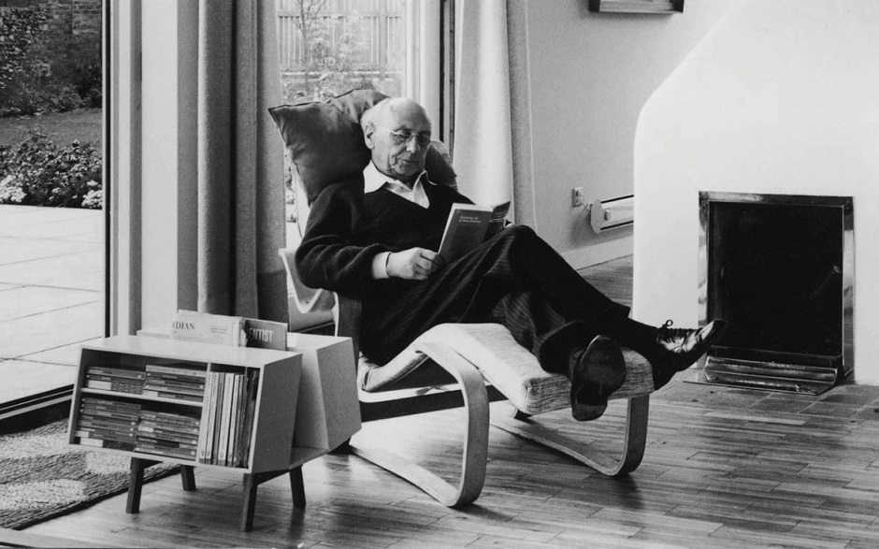

Jack Pritchard in Marcel Breuer's long chair with Ernest Race’s Donkey bookcase

<http://insidemodernism.co.uk/wp-content/uploads/2013/07/pritchard_featured.jpg>

Jack Pritchard was a British furniture manufacturer and design patron who co-founded the Isokon design company in 1931. Under his leadership, Isokon developed mass-produced, standardised housing and furniture based on the principles of European modernism. Among the most important early advocates of modernism in Britain, Pritchard encouraged the use of materials such as concrete, steel and plywood as the basis of modern design. As a patron, he built Lawn Road Flats in Hampstead, the first example of modernist mass-housing in Britain, and commissioned leading European designers to produce furniture for Isokon.

Pritchard was born in Hampstead, London in 1899. He studied engineering and economics at Cambridge University, graduating in 1922. After marrying the bacteriologist Rosemary (Molly) Cooke (1900-1985), he took a job at the Venesta Plywood Company in 1925. Pritchard was eager to develop plywood as a material suitable for domestic furniture. In 1929 he encountered the innovative plywood shop-fittings designed by Wells Coates for Cresta Silks (1929-32), which revealed the aesthetic potential of plywood as a material for modern design. Pritchard and Coates founded Wells Coates and Partners in September 1930. However, Pritchard came to feel that Coates was too dominant. The foundation of Isokon Limited in December 1931 was a tactical move: Pritchard effectively ran the company, hiring designers and directing the marketing. The name was derived from the term Isometric Unit Construction, owing to Coates’s preference for isometric drawing.

At the same time, Pritchard became passionately committed to the ideals of European modernism. He was familiar with the work of Le Corbusier and Charlotte Perriand, and attended the Weissenhof Seidlung exhibition in Stuttgart, Germany. He also visited the Dessau Bauhaus in March 1931. The founding of Isokon was among the first attempts to develop modernist ideas in Britain. Houses were to be built on the principle of standardised units, allowing interior elements such as furniture to be fitted ‘into any shell that the Company may build’ (Isokon company memo, 1932). The Pritchards commissioned Coates to design a block of flats according to Le Corbusier’s principle of the ‘minimum dwelling’. The resulting building, Lawn Road Flats in Hampstead (1933-4), became the serene flagship of British modernism. Constructed from reinforced concrete, its white façades were articulated with cantilevered sculptural stairways and access galleries. The flats were aimed at a professional elite, rather than the average house buyer. Indeed, some of the first tenants were leading modernist designers escaping oppression in Nazi Germany, including Walter Gropius, Marcel Breuer, and László Moholy-Nagy, as well as novelist Agatha Christie. The Pritchards lived in a penthouse flat added to the building after the initial construction had been completed.

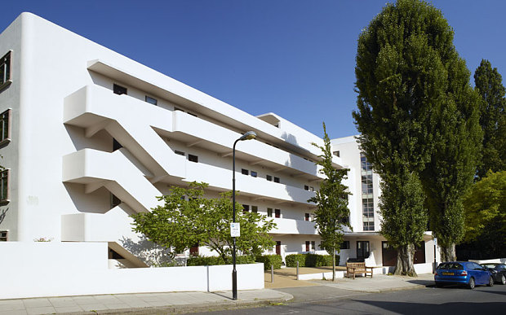

Wells Coats, Lawn Road Flats, London (1933-34) <http://i.telegraph.co.uk/multimedia/archive/03022/summary_3022871b.jpg>

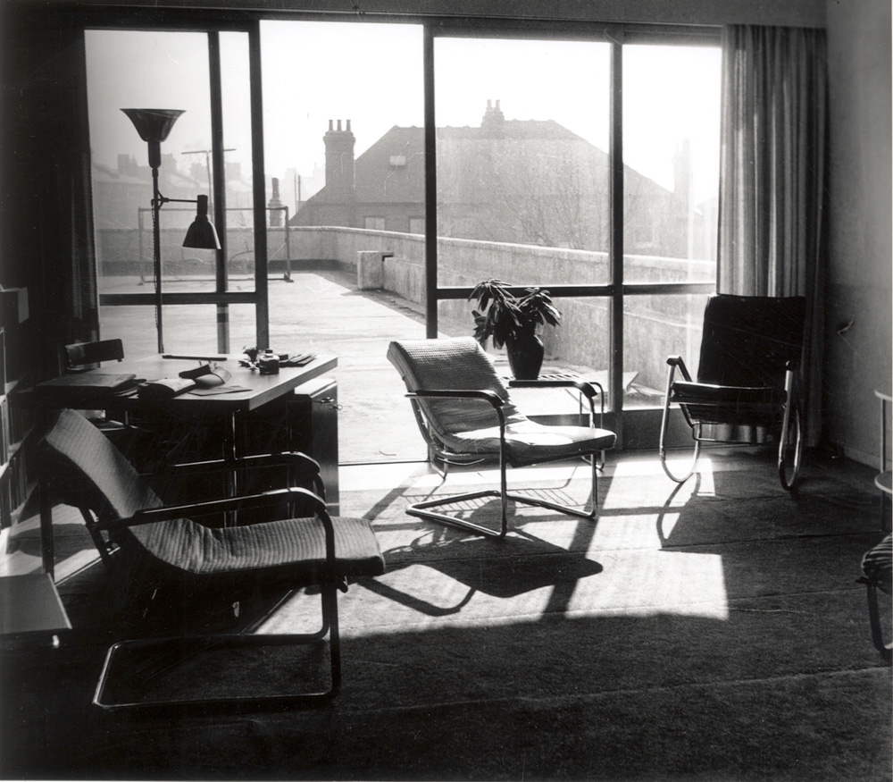

Jack Pritchard’s apartment in Lawn Road Flats

<http://restlesshungarian.com/wp-content/uploads/2015/04/interior-penthouse.jpg>

Pritchard established the Isokon Furniture Company in January 1936 to place renewed emphasis on furniture production instead of architecture. This echoed the Bauhaus’s utopian ideals of good, functional design for the masses. Former Bauhaus designers Gropius and Breuer were commissioned to produce furniture designs for the company. By virtue of working for Venesta, Pritchard was able to obtain a 25% discount on plywood. Specifically, the focus was on moulded plywood, as opposed to more conventional techniques. Breuer in particular was able to exploit the intrinsic properties of the material.

Isokon was not a commercial success and struggled to reach beyond the avant-garde circles in which Pritchard and Coates moved. The outbreak of World War II cut off Isokon’s supply of plywood and the lack of financial support led to the company’s demise. Nevertheless, Pritchard’s commitment to standardised housing and modern materials confirms his status as one of the leading champions of modernism in Britain. Pritchard retired in the 1960s. His daughter Jennifer and her husband Colin Jones designed a house, ‘Isokon’ in Dunwich Road, Blythburgh, Suffolk, where he lived during his retirement.

**Further reading**

# Buckley, C. (1980) *Isokon: Architecture, Furniture and Graphic Design, 1931-1939*. Newcastle: University of Newcastle.

# Grieve, A. (2004) *Isokon: For Ease, For Ever.* London: Isokon Plus.

# Pritchard, J. (1984) *View from a Long Chair: the memoirs of Jack Pritchard*. London: Routledge.